**Process**

**Definition**

**Document**

*Vendor Onboarding Process*

Document History

|  |  |  |  |  |
| --- | --- | --- | --- | --- |
| **Date** | **Version** | **Role** | **Name** | **Comment** |
| 04/09/2025 | 1.0 | Business Analyst | Amr Ayman | Created initial draft |
|  |  |  |  |  |
|  |  |  |  |  |
|  |  |  |  |  |

Contents

I. Introduction 3

1.1. Purpose 3

1.2. Objectives 3

1.3. Process key contacts 3

1.4. Minimum prerequisites for the automation 4

II. As-is process description 4

2.1. Process overview 4

2.2. Applications used 5

2.3. As-is process map 5

2.3.1. High-level process map 5

2.3.2. Detailed level process map 6

2.4. Detailed as-is process actions 6

III. To-be process description 6

3.1. Detailed to-be process map 6

3.2. Input/Output data description 6

3.3. Exceptions Handling 7

3.4.1. Known business exceptions 7

3.4.2. Unknown business exceptions 7

3.4. Applications errors and exceptions handling 7

3.5.1. Known applications errors and exceptions 7

3.5.2. Unknown applications errors and exceptions 8

3.5. Reporting 8

3.6. In scope for automation 8

3.7. Out of scope for automation 8

3.8. Change/Improvement details 9

IV. Other 9

4.1. Additional sources of process documentation 9

4.2. Change requests 9

4.3. Document approval 10

# Introduction

## Purpose

The Process Definition Document outlines the business process chosen for automation. The document describes the sequence of actions performed as part of the business process, the conditions, and rules of the process prior to automation (as-is) as well as the new sequence of actions that the process will follow as a result of preparation for automation (to-be).

**The PDD is a communication document between:**

* The Automation Business Analyst and the SME/Process Owner. The goal is to ensure that the Automation Business Analyst has the correct understanding of the process and has represented it accurately.
* The Automation Business Analyst and the Development team (represented by the Solution Architect and Automation Development Lead). The goal is to ensure that the process is documented appropriately and to a sufficient level of detail so that the Solution Architect can then create the solution based on the PDD content.

## Objectives

The business objectives and benefits expected by the Business Process Owner after automation of the selected business process are:

* Reduce processing time per item.
* Eliminate human error.
* Reduce Operational delays
* Eliminate manual Person dependent process

## Process key contacts

The specifications document includes concise and complete requirements of the business process, and it is built based on the inputs provided by the **process** **Subject Matter Expert (SME)/ Process Owner.**

The **Process Owner** is expected **to review it and provide signoff for accuracy** and completion of the steps, context, impact, and complete set of process exceptions.

The names have to be included in the table below.

|  |  |  |
| --- | --- | --- |
| Role | Name | Contact Details |
| **Automation Developer** | Joe Bratt | Joe.bratt@mail.com 123-234-2222 |
| **Business Analyst** | Ron Cooper | Ron.cooper @mail.com 123-234-2234 |
| **Solution Architect** | Charlie Pierce | Charlie.pierce @mail.com 123-234-2211 |
| **Project Manager** | Maryam Holden | Maryam.holden @mail.com 123-234-4357 |
| **Process SME / Process reviewer** | Tiffany Caldwell | Tiffany.caldwell @mail.com 123-234-8637 |
| **Process Owner/ Approver for production** | Joe Bratt | Joe.bratt@mail.com 123-234-2222 |

## Minimum prerequisites for the automation

* Filled in Process Definition Document
* Test Data to support development.
* User access and user accounts creations (licenses, permissions, restrictions to create accounts for robots)
* Credentials (user ID and password) required to log on to machines and applications.

# As-is process description

In this section the Business Analyst will document the process. This section will serve as the starting point for the re-engineering and automation effort.



## Process overview

The section contains general information about the process before automation.

The manual process for vendor onboarding process of ACME Systems Inc. is:

1. The executive reads the mails received from the vendor and downloads the attachments.
2. Check that all the vendor details are present. Also, check that the Tax ID has a valid format.

* If not, send an email to the vendor that a particular detail is not present, or the Tax ID has nvalid format.

1. Log in to the ERP application and check that the vendor details do not exist in the database of the application using the Tax ID.

* If the Tax ID matches with the existing entries, send email to the vendor that the vendor already exists in the system.

1. Log in to the CRM application and check that the vendor details do not exist in the client database using the Tax ID.

* If the Tax ID matches with the existing Client entries, send email to the vendor that the vendor already exists in the system.

1. Enter the details of the vendor (Vendor Tax ID, Name, Address, City, and Country) in the ERP application to add the vendor.
2. When all the transactions have been processed, create an MIS report.
3. After completing the process, send the MIS report to the support team.

|  |  |
| --- | --- |
| Item | Description/Answer |
| **Process Full Name** | Vendor Onboarding Process |
| **Process Area** | Accounts |
| **Department** | Accounts |
| **Short Description (operation, activity, outcome)** | Extract details from the vendor onboarding form and insert vendor details in ERP Application. The MIS is prepared and shared with the business team. |
| **Role(s) required in applications to perform the process** | ACME System 1 and ACME System 3 user |
| **Process schedule and frequency** | Daily |
| **Number of times the process is ran by selected frequency** | 1 |
| **Average handling time per item** | 20 minutes |
| **Process Restrictions** | **The applications can be used only between 7 AM-8PM during workdays and not allowed to be used during weekends.** |
| **Peak Period (s)** | **Beginning of the month** |
| **Peak Volume Approximate increase** | 225 vendors daily |
| **Total # of FTEs supporting this activity** | ***15*** |
| **Expected Volume increase during next periods** | NA |
| **Level of exception rate** | ***NA*** |
| **Input data description** | ***Mail with attachment vendor information (pdf & word)*** |
| **Output Data description** | **Vendor details uploaded in ACME with MIS** |

## Applications used

The table includes a comprehensive list of all the applications that are used as part of the process to be automated to perform the given actions in the flow.

|  |  |
| --- | --- |
| Application Name | Details (Version, Language, Environment/ Access method) |
| ACME system 1 | 2020.1 |
| ACME system 3 | 2020.1 |
| MS outlook | 2023 |
| MS Excell | 2311 |
|  |  |

## As-is process map

This section contains various process maps contributing to a better understanding of how the process is performed pre-automation.

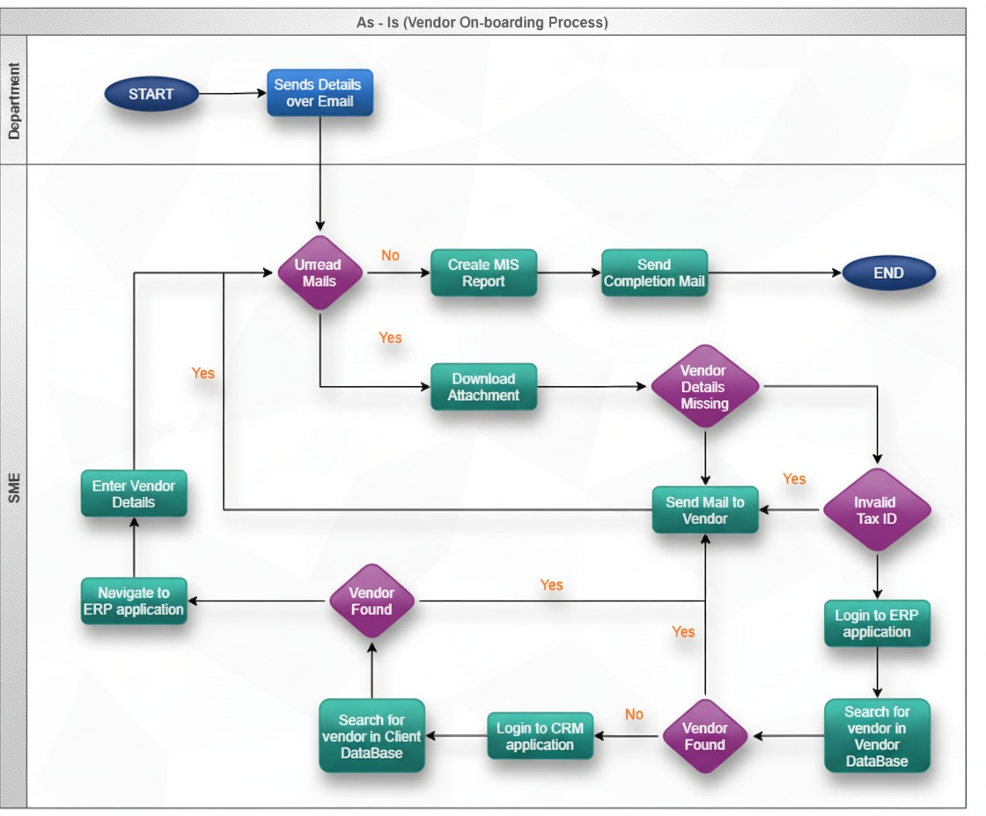

### High-level process map

This section is useful for the Business Analyst in presentations and discussions with management to underline areas of weakness, inefficiency or to demonstrate which actions could be in scope for automation.

|  |  |
| --- | --- |
| **Step** | **Short Description** |
| 1 | Read Mails |
| 2 | For Each Mail |
| 3 | Download Attachment |
| 4 | Extract Data from mail attachment |
| 5 | Search for Tax ID in the mail attachment |
| 6 | Open ACME System 1 Web Application |
| 7 | Log in to System 1. Required data: Email and Password |
| 8 | Access the Dashboard- the central location, where the user can pick a specific menu item |
| 9 | Access the ‘Search for Vendor’ page in the ‘Vendors’ section. |
| 10 | Enter Tax ID in Search for Vendor page and Click Search button. |
| 11 | Log in to System 3. Required data: Email and Password |
| 12 | Search for the Tax ID |
| 13 | Open ACME System 1 and Navigate to Dashboard |
| 14 | Access ‘Add Vendor’ Page in the Vendors section |
| 15 | Enter Vendor Tax ID, Vendor Name, Address, City and Country extracted from the mail attachment. |
| 16 | Click on Save Vendor button and Update the MIS DataTable’s Status column as  ‘Completed’ |
| 17 | If there are no mails to be processed. |
| 18 | Create MIS Report. |
| 19 | Send mail to the concerned department. |

### Detailed as – is process steps

This section describes the process at key-stroke level and is an essential part for the communication with the developers.

|  |  |  |  |  |  |
| --- | --- | --- | --- | --- | --- |
| **#Action** | **Input** | **Description** | **Details** | **Exception Handling** | **Possible Actions** |
| 1 | Unread Mails |  |  | 1. Mailbox not configured 2. Invalid Mail Subject Format | Reading Unread Mails with a pre- defined mail subject: “New Vendor received” |
| 2 |  | Download Attachment | Vendor.xlsx Vendor.pdf | Attachment not Found | 1. Save attachment in the Input folder. 2. If attachment not found, Notify Vendor |

|  |  |  |  |  |  |
| --- | --- | --- | --- | --- | --- |
|  |  |  |  |  | 3. If more than one attachment  found, Notify Vendor |
| 3 | Vendor Onboarding Form (PDF (Native or Scanned)/Exc el) | Extract Data from mail attachment |  | Invalid File Type | 1. Store the vendor details in a Data Table. 2. Update MIS Report. 3. If Invalid File Type found, Notify Vendor |
| 4 |  | Check for the vendor details and validate Tax ID |  | 1. Vendor Details missing 2. Tax ID   not valid | 1. Vendor Details should not be empty 2. Update MIS Report 3. If vendor details missing, Notify vendor. 4. If Tax ID is not valid, Notify Vendor. |
| 5 |  | Open ACME  System 1 Web  Application. |  | Webpage not responding | Restart the browser. |
| 6 |  | Log in to System 1. Required input data: Email and Password |  | Wrong Credentials | 1. Login to   ACME System 1 using the Credential Asset (ACME_Credent ial)   1. If Invalid Credentials found, Notify Support Team |

|  |  |  |  |  |  |
| --- | --- | --- | --- | --- | --- |
| 7 |  | Access the Dashboard- the central location, where the user can pick a specific menu item. |  |  | Click on the ‘Home’ button |
| 8 |  | Access the ‘Search for Vendor’ page in the ‘Vendors’ section. |  |  | From the Vendors tab, select Search for Vendor option from the drop-down menu. |
| 9 |  | Enter Tax ID in Search for Vendor page and Click Search button. |  | Tax ID found. | 1. Enter the Tax ID in the Vendor Tax ID section and select the Search button 2. Update MIS Report 3. If vendor is present in   database, Notify Vendor |
| 10 |  | Log in to System 3. Required input data: Email and Password |  | Application Crashes | Login to ACME System 3 |
| 11 |  | Search for the Tax ID in Client Data. |  | Tax ID found. | 1. Update the MIS Report 2. If a vendor is present in database, Notify Vendor |

|  |  |  |  |  |  |
| --- | --- | --- | --- | --- | --- |
| 12 |  | Open ACME  System 1 and Navigate to Dashboard |  |  | Navigate to Vendors>Add Vendor |
| 13 |  | Access ‘Add Vendor’ Page in the Vendors section |  |  | Click on Add Vendor Page |
| 14 |  | Enter Vendor Tax ID, Vendor Name, Address, City and Country extracted from the mail attachment. |  |  |  |
| 15 |  | Click on Save Vendor button and Update the MIS  DataTable’s Status column as  ‘Completed’ |  |  | Update MIS Report |
| 16 |  | Create MIS Report. | MIS Report.xlsx |  |  |

|  |  |  |  |  |  |
| --- | --- | --- | --- | --- | --- |
| 17 |  | Send mail to the concerned department. |  |  | Send mail to business team with MIS Report as Mail  Attachment |

# To-be process description

In this section the proposed improvements to the process, actions to the process will be outlined as well as the actions proposed for automation and the type of robot required. This will be cross-checked by the Solution Architect.



## Detailed to-be process map

All Process is automated using RPA.

## Input/Output data description

The following table should contain details regarding the inputs that every action of the process takes.

|  |  |  |  |  |  |  |
| --- | --- | --- | --- | --- | --- | --- |
| **#** | **Sample** | **Type** | **Process step #** | **Storage location** | **Are inputs Natively Digital*?** | **Are the inputs Structured*?** |
| 1 | Vendor.pdf | PDF | 2 | Input Folder | Yes | Yes |
| 2 | Vendor-photo.pdf | PDF | 2 | Input Folder | No | Yes |
| 3 | Vendor.xlsx | Excel | 2 | Input Folder | Yes | Yes |

## Exceptions Handling

The Business Process Owner and Business Analysts are expected to document below all the business exceptions identified in the automation process. Exceptions are of 2 types, and both need to be addressed:

* **Known exceptions** - previously encountered. A scenario is defined with clear actions and workarounds for each case.
* **Unknown exceptions** - New situation that was not encountered before. It cannot be predicted and in case it happens it needs to be flagged and communicated to an authorized person for evaluation.



### Known business exceptions

Details regarding how the robot should handle the exceptions.

|  |  |  |  |  |
| --- | --- | --- | --- | --- |
| **#** | **Exception Name** | **Action** | **Parameters** | **Actions to be taken** |
| 1 | Tax ID found in ACME System 1 | 9 | VendorTaxID | Send an e-mail to vendor with the text: Vendor is already added in our system.” Go to the next transaction |
| 2 | Tax ID found in ACME System 3 | 11 | VendorTaxID | Send an e-mail to vendor with the text: Vendor is already added in our system.” Go to the next transaction |
| 3 | Input File Type | 3 | InputFileType | Send an e-mail to vendor with the text: Invalid FileType received.” |
| 4 | Email Subject | 1 | MailSubject format is not supported | Send an e-mail to vendor with the text: Incorrect Format of the Subject.”  Go to the next transaction |
| 5 | Attachment not present | 2 | Input Folder is Empty | Send an e-mail to vendor with the text: Vendor onboarding form is missing in the mail.”  Go to the next transaction |
| 6 | Relevant Fields | 4 | VendorName/ VendorAddress/ VendorCity/ VendorCountry | Send an e-mail to vendor with the text: Data missing for ‘x’ field.”  Go to the next transaction |
| 7 | Invalid Credentials | 6 | Invalid Credentials | Send an e-mail to support team with the text: Invalid Credentials.”  Go to the next transaction |

### Unknown business exceptions

An umbrella rule that includes a notification needs to be designed for all other exceptions that could happen and cannot be anticipated.

***F****or all other cases which do not follow the rules defined an e-mail should be sent to:* [exceptions@acme.com](mailto:exceptions@acme.com) *with a screen shot and robot should proceed to next transaction.*

## Applications errors and exceptions handling

A comprehensive list of all errors, warnings or notifications should be consolidated here together with the action to be taken for each by the Robot. There are 2 types of exceptions/errors:

**Known** - previously encountered and action plan or workaround available for it (e.g. SAP unresponsive during peak times)

**Unknown** - these are exceptions and errors that cannot be anticipated but for which the robot needs to have a rule so that the automation solution is sustainable.



### Known applications errors and exceptions

Details regarding how the robot should handle the exceptions.

|  |  |  |  |  |
| --- | --- | --- | --- | --- |
| **#** | **Error/Exception Name** | **Action** | **Parameters** | **Actions to be taken** |
| 1 | Application (Crash / Non-Responsive) | 10 | Application Unresponsive | Recover and retry 3 times |
| 2 | Webpage not loaded | 5 | Webpage Unresponsive. | Recover and retry 3 times |
|  |  |  |  |  |

### Unknown applications errors and exceptions

An umbrella rule that includes a notification needs to be designed for all other exceptions that could happen and cannot be anticipated.

*e.g. robot should attempt to access the application 3 times then it should terminate thread.*

## Reporting

In this section all the reporting requirements of the business should be detailed so that when the automation solution is moved to production the administrators can track the performance of the solution.

|  |  |  |  |
| --- | --- | --- | --- |
| Report Type | Update frequency | Details | Monitoring Tool to visualize the data |
| Process logs | Daily | How many times was this process run since the beginning of the month and what was the average run duration | Orchestrator |
| Transaction logs | Daily | How many transactions were run by this process since the beginning of the month and what was the average transaction duration? | Orchestrator |
| Error logs | Daily | Average number of errors by type per day | Orchestrator |
| MIS report | Daily | All transactions processed during the day | Excel file over an email to be sent |

## In scope for automation

The actions in scope for automation should be listed below:

* All Actions are in scope of RPA

## Out of scope for automation

The actions **out of scope** for automation should be listed below together with the reasoning:

* Nothing out of scope

## Change/Improvement details

Use this section to detail the list the change or improvement opportunity in the To-Be Process.

Important aspects to be mentioned: what is the initiative, expected outcome, expected completion date, contact person for details, and if will impact the current automation request.

|  |  |  |  |  |  |
| --- | --- | --- | --- | --- | --- |
| # | Initiative Name | Process Action(s) where it is identified | Impact on current Automation Request | Expected Completion Date | Contact Person |
|  |  |  |  |  |  |
|  |  |  |  |  |  |
|  |  |  |  |  |  |

# Other



## Additional sources of process documentation

|  |  |
| --- | --- |
| Item | Location |
| **Video Recording of the process (Optional)** |  |
| **Business Rules Library (Optional)** |  |
| **Other documentation (Optional)** |  |
| **Standard Operating Procedure(s) (Optional)** |  |
| **High Level Process Map (Optional)** |  |
| **Detailed level process map (Optional)** |  |
| **Work Instructions (Optional)** |  |
| **Input Files (Optional)** |  |
| **Output Files (Optional)** |  |

## Change requests

|  |  |  |  |  |  |
| --- | --- | --- | --- | --- | --- |
| # | Date | Change description | Affected process steps / section | Change reason | Change initiator |
|  |  |  |  |  |  |
|  |  |  |  |  |  |
|  |  |  |  |  |  |

## Document approval